Bootloader Installation Procedure

The first thing that needs to be done after completion of the UI board is to program the bootloader.
There are different procedures possible (programming via ST-LinkV2, use DFU mode of STM) – here I explain programming bootloader via DfuSeTools from ST usind PC running „Windows“.

First download DfuSETools from ST: http://www.st.com/en/development-tools/stsw-stm32080.html
Install it and start the application. Connect USB-cable with mini USB plug on the other side of cable.

Do not play with any option bytes (if you lock the fuses, the MCU can become useless)!
Now to enter DFU mode on UI-board. Do not connect RF and UI board – use single UI board.
Single UI board can be used in the next step also for loading, the first time, the firmware.
Then the UI board has to be powered directly as decribed in next point 3.
1. Close P6 jumper at the bottom of the UI board
2. Press and hold BAND+ button, it is MANDATORY to be performed before powering the board
3. Connect 5V between pin28 and the ground pin 30 of P1, the interconnection of the two boards. 8V and 3.3V are not required. You will get a white screen now – that‘s ok!
4. Connect USB plug from PC to small USB connector, it is immaterial if done before or after powering the board
5. Release BAND+ if a new device is recognized. If the PC doesn’t recognize the device some harware problem may be present.
6. Let Windows finish driver installation procedure. Some OS (e.g. windows 10), after the device is recognized, find the driver automatically, eventually after repeating the procedure a few times. Some other doesn’t find it, you have to give it manually. You can find the driver in C:\ProgramFiles (x86)\STMicroelectronics\Software\bin.

Now get a bootloader (dfu extension). There are two different bootloaders available:
1. DF8OE bootloader (you can do firmware updates without PC using a simple USB key). You can get this
bootloader from GitHub https://github.com/df8oe/mchf-github/releases
2. M0NKA bootloader (you have to use close source mchf-manager and PC for fw-upgrade, bootloader does not
support „reboot function“ of firmware). M0NKA bootloader is availble at http://www.m0nka.co.uk/?page_id=5269

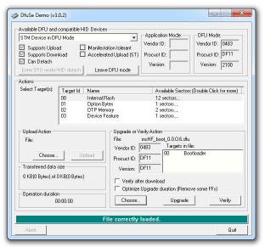
1. If you can see (A) „STM Device in DFU Mode“ in the left upper box connection between STM
(A) MCU and program is working.

2. Now press (B) „Choose...“ located in the right down area and select the downloaded bootloader file with extension „.dfu“.

3. Set a mark to (C) „Verify after download“ in the same area.

4. Press (D) „Upgrade“ in the same area. It will take a few seconds and then process hopefully is finished successfully.
(C)
5. Now disconnect power from UI board and
(B) (D) remove jumper P6.

(E) 6. You are ready to apply firmware now!

V1.0, DF8OE, 17.12.2016

