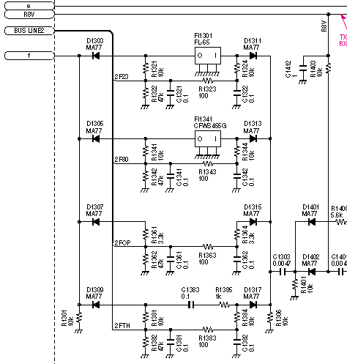

If filter blow-by is a problem when using narrow CW filter option, remove D1309 or D1317. This will remove the “no filter” bypass circuit and eliminate capacitive coupling through the diodes to the rest of the IF chain. These diodes are on bottom of the board near the option filter position. They are MA77 diodes if they are needed later for replacement. de K0ZL

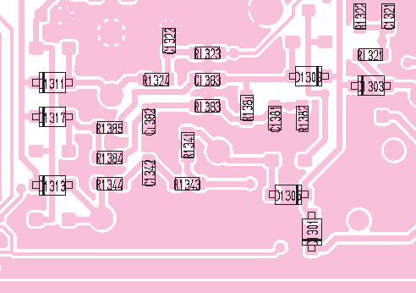

Fig. 1. IC-703 2nd IF Filtering
Fig. 2. IC-703 2ND IF Filter Location

