Mockingboard v1 Parts List

16 - .1uF cap 2 – 1N4148 diode 3 – 10k resistor 2 – 8k resistor 2 – 10 ohm resistor 1 – 5.25” Test Disk
5 – 10uF cap 1 – 3.5 mm stereo jack 5 – 1k resistor 4 – 3.3k resistor 5 – 4.7 resistor 2 – 2k resistor
1 – 5pF cap 1 – Speaker header pins 1 – 74LS05 IC 2 – LM386 IC 2 – AY-3-8913 IC 2 – 6552 IC
3 – 220uF cap 2 – AMP MTA connector 1 – 1’ Speaker wire 9 – Machine pin socket – for all IC’s 0 – SSI-263 Speech (sold separately)

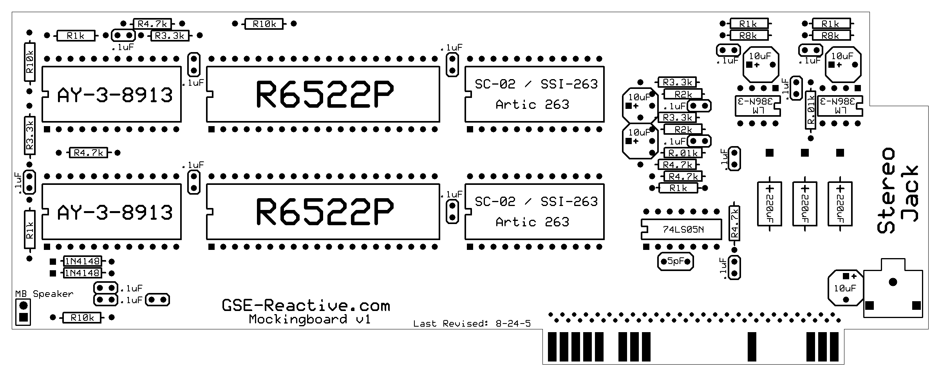
Note: Pay attention to the “Positive” side of the 10uF caps, 220uF cap and 1N4148 diodes and make sure to install them in the correct polarity on the card. The 10uF caps have a “line” and a small “+” sign on the positive side and the card is marked with a “+” sign to denote positive. The 220uF caps have a “line” and a small “-” with an “>” sign pointing toward the negative side and the card is marked with a “+” sign to denote positive. The diodes have a black “stripe” that run the circumference on the glass casing that denotes the negative side. Make sure the stripe on the diode is facing the Stereo Jack on the card. The card has “square” pads (the hole you solder the part in to) to denote the POSTIVE side of ALL items with a polarity or “Pin 1” of the IC’s. Note the LM386 IC’s are facing a different direction then the rest of the IC’s. Make sure to install all items correctly or damage to the card and/or computer might occur. If you are in ANY doubt about the polarity of an item please don’t hesitate to contact Support at GSE-Reactive.com. It’s better to be safe then sorry and replacement parts WILL cost extra! All parts are tested before shipping. Make sure to wear a Ground Strap and take all precautions to prevent static when handling or working with the IC’s, even when they are installed on the card. The SSI-263 Speech IC is sold separately and usually available at
GSE-Reactive.com in the on-line Store. Thank you for your order!

