This article was provided by (waiting for permission to include their name)

How to connect a Standard-MSDOS-Drive (360k-5.25" or 720k-3.5") to an AEPC-Transporter Card.

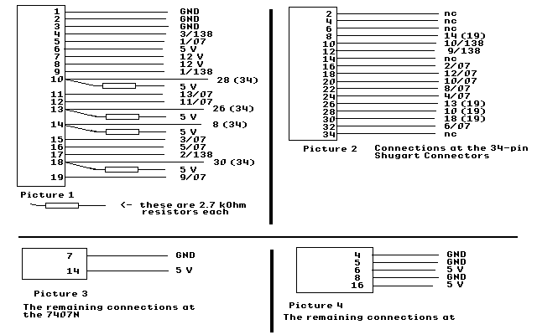
(Translated from a publication in the German AUGE-User-Magazine 7/88)
You need the following parts:
1 or 2 Shugart-Bus-Connectors (female, 34pins)
1 Apple Disk-Port-Connector (male, 19pins)
about 50 cm of cable (which allows you to connect 19 pins)
about 50 cm of cable for the 34-pin-Shugart-connectors
1 IC 7407N
1 IC 74LS138/1
2 capacitors of each 100nF
4 resistors of each 2.7kOhm
2 sockets (better) for the ICs
1 little testing board
The best way to build this adapter (interface?) is to do it with a little board (about 3 by 3 inches). First solder the two sockets, then solder each of the described connections - one by one.
The second MSDOS-Drive is connected parallel to the first - addressing is done by setting the drive-select-jumper to D1, if the first is D0 (or D2, if the first was D1).
The PICTURE 1 on the attached PCT.DRIVES.PIC shows the first set of connections - the one from the 19pin-Apple-Disk-Connector! - you have to make. Syntax: (1/07 means: connected to Pin 1 of the IC 4707; 2/138 means connected to pin 2 of the 74138; 28 (34) means a connection to pin 28 of the 34pin-Shugart-Connector. GND means connected to ground. All the resistors in this picture have a value of 2.7 kOhm.)
The numbers in the box on the left side represent the pins of the 19 pin Apple-Disk-Connector.
PICTURE 2 shows the additional connections referring to the 34pin-Shugart-connector. (Syntax is the same as above, 10 (19) means connect to pin 10 of the 19 pin Apple-disk-connector, nc means "not connected", of course :-)!)
All odd pins of this connectors have to be connected to GROUND!
Now for the additional connections you have to make on the two ICs:
7407: Pin 7 -> Ground, Pin 14 -> 5V. (PICTURE 3)
74138: Pins 4,5,8 -> Ground, Pins 6,16 -> 5V. (PICTURE 4)
Now connect Pins 7 and 14 of the 7407 via one of the capacitors, the same goes with the pins 8 and 16 of the 74138.
Daisy Chaining not implemented, sorry - if you need it badly: ask back - but you'll do it at your own risk! The Apple-Platinum-drive is much more expensive than a MSDOS-drive!
That's all folks!
Have fun and: Greetings from Germany.
---> Apple II forever! <---

