UDC ‘Long’ Card Floppy Drive Cable Pinouts

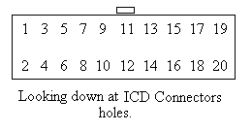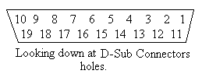

20 Pin IDC Connector - Female 19 Pin D-Sub Connector – Female

1 --------------------------- 16
2 --------------------------- 11
3 --------------------------- 2
4 --------------------------- 12
5 --------------------------- 3
6 --------------------------- 13
7 --------------------------- 4
8 --------------------------- 14
9 --------------------------- 5
10 -------------------------- 15
11, 12 ---------------------- 6
13, 15 ---------------------- 7
14 -------------------------- 17
16 -------------------------- 18
17, 19 ---------------------- 8
18 -------------------------- 19
20 -------------------------- 10

The metal shield around the D connector is not connected to anything.

